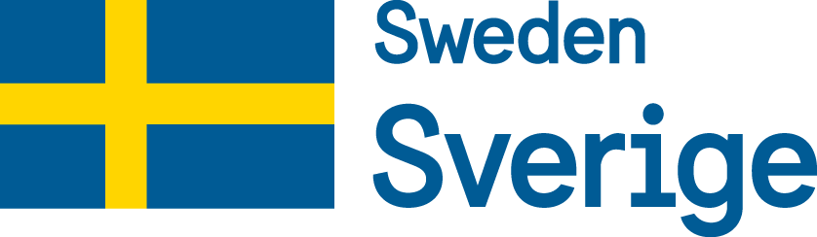 | 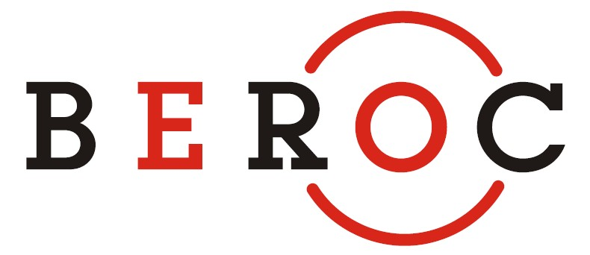 | 

Beijing Hotel
Lotus Hall
36, Krasnoarmeiskaya Street, Minsk, Belarus

THE CONFERENCE OF YOUNG RESEARCHERS IN ECONOMICS AND FINANCE

December 22, 2018

09:30-10:00 | Registration of participants  Welcome coffee
10:00-10:40 | Inflation Expectation Formation: Laboratory Experiment in High and Low Inflation Environment  Daria Minina, Tinbergen Institute
10:40-11:20 | Using Microdata on Companies to Monitor Financial Stability  Alexander Novopoltsev, Belarusian State University
11:20-11:40 | Coffee break
11:40-12:20 | Banking Crises, Sovereign Default and Macroprudential Policy  Aliaksandr Zaretski, Emory University
12:20-13:00 | Is There a Bank Lending Channel of Monetary Transmission in Belarus? (joint with Victoria Utesheva)  Anatoli Kharytonchyk, National Bank of Belarus
13:00-14:00 | Lunch
14:00-14:40 | The Anatomy of Medical Research: Public Owners Behind Private Firms  Slavek Roller, Goethe University Frankfurt
14:40-15:20 | Does Community Monitoring Increase the Effectiveness of Public Procurement (joint with Svetlana Pivovarova)  Hanna Charankevich, University of Virginia
15:20-15:40 | Coffee break
15:40-16:20 | A Dynamic Model for Optimal Covenants in Loan Contracts  Marina Tulyakova, University of Trento
16:20-17:00 | TBA  Kristina Manysheva, Northwestern University

